EWMA correlation: EURUSD and AUDUSD
Method 06 / daily log returns / lambda = 0.94 / Alpari D1 full available history

Study setup
Logical pair: EURUSD , AUDUSD
Broker symbols: EURUSD_i , AUDUSD_i
Snapshot: 2026-11-03_majors_alpari_D1
Timeframe: D1
Matched return window: 1999-01-05 to 2026-11-02 (UTC bar dates)
Matched return count n: 7201
Dropped unfinished last bar dated 2026-11-03 UTC after a tick-volume check against the prior complete day.
Lambda: 0.94 (today weight 0.06)
Burn-in ignored in path summaries and chart: first 60 updates
Mean adjustment: each leg demeaned by its mean on the matched rows
Seeds: c_0 = v_x,0 = v_y,0 = 0
Complete matched rows (Excel): EURUSD-AUDUSD_EWMA_D1.xlsx
Complete matched rows (HTML table): EURUSD-AUDUSD_EWMA_D1_data.html

Method carried forward
EWMA correlation updates covariance and variances of mean-adjusted daily log returns of close, ln(close_t / close_t-1), with lambda = 0.94 (6% weight on today's product or square, 94% on yesterday's EWMA state). Quotes are not inverted. Each leg is demeaned by its mean on the matched rows; that mean uses the full sample, so the rho path is a full-sample description, not a live filter. Seeds start at zero. Path summaries and the chart ignore the first 60 updates so the zero seed has faded. The headline is rho on the last day. rho is symmetric under swap of the two symbols. A high |rho| does not prove cause, lead-lag, or a trading signal. Today's return sits inside today's rho, so the estimate can only inform a later decision. Same-sample Pearson r is a side check only.

Results
Latest EWMA rho: 0.141725
Post-burn-in path (n=7141): mean=0.549880, median=0.602595, min=-0.412310, max=0.925362, std=0.214124
Share of post-burn-in days with |rho| >= 0.4: 76.80%; |rho| >= 0.7: 28.83%
Same-sample Pearson r: 0.556324
Latest rho minus r: -0.414599

Conclusion
Over 7201 matched daily log-return rows for EURUSD and AUDUSD (broker quote directions unchanged), latest EWMA rho with lambda=0.94 is 0.1417 (positive, weak recent linear link in this sample). After a 60-day burn-in, path mean is 0.5499, std is 0.2141, and the range is [-0.4123, 0.9254]. Same-sample Pearson r is 0.5563 (latest rho minus r = -0.4146). This does not establish cause, lead-lag, or a lasting trading rule.

Charts
Daily closes

Daily log returns
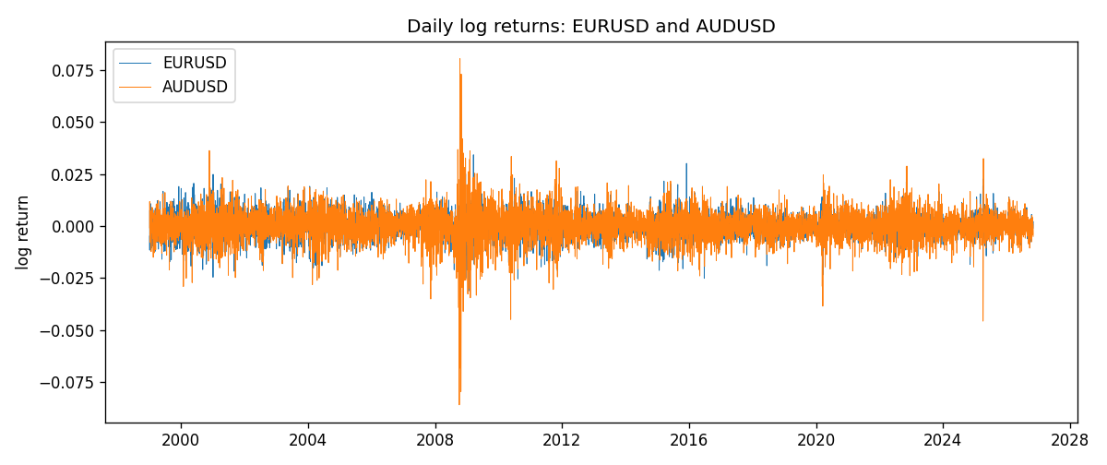
EWMA rho path with Pearson r reference
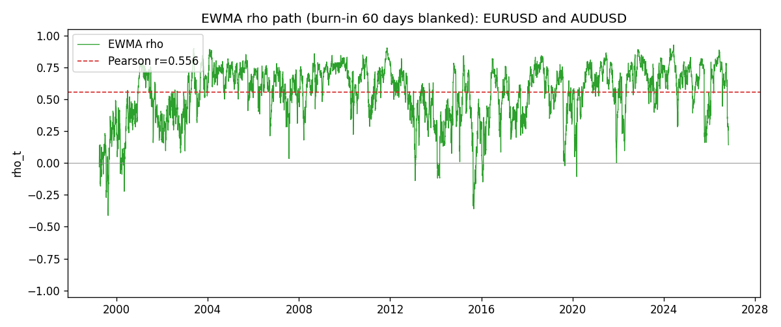

Data report
Every matched row that entered the EWMA recursion is stored in the sibling Excel workbook named EURUSD-AUDUSD_EWMA_D1.xlsx. That file is the complete data archive for redrawing charts. Embedding all rows as a Word table is impractical at this length; the Word file holds the column list, column summaries, and the first and last 15 matched rows.
Columns: time, EURUSD_open, AUDUSD_open, EURUSD_high, AUDUSD_high, EURUSD_low, AUDUSD_low, EURUSD_close, AUDUSD_close, EURUSD_tick_volume, AUDUSD_tick_volume, EURUSD_spread, AUDUSD_spread, EURUSD_real_volume, AUDUSD_real_volume, EURUSD_log_return, AUDUSD_log_return, EURUSD_x_demeaned, AUDUSD_y_demeaned, c_t, v_x, v_y, rho_t
Column summaries (matched calculation rows)
column | count | mean | std | min | 25% | 50% | 75% | max
EURUSD_open | 7201 | 1.1813268 | 0.15086382 | 0.8272 | 1.08608 | 1.16615 | 1.29393 | 1.5995
AUDUSD_open | 7201 | 0.75197127 | 0.13525779 | 0.4785 | 0.66105 | 0.73142 | 0.80912 | 1.10284
EURUSD_high | 7201 | 1.1864593 | 0.1514619 | 0.8326 | 1.0902 | 1.17128 | 1.29926 | 1.6038
AUDUSD_high | 7201 | 0.75602178 | 0.13581838 | 0.4878 | 0.6647 | 0.7349 | 0.81518 | 1.10795
EURUSD_low | 7201 | 1.1763142 | 0.15018707 | 0.8227 | 1.08202 | 1.16257 | 1.28834 | 1.5865
AUDUSD_low | 7201 | 0.74791431 | 0.13457219 | 0.4775 | 0.6577 | 0.72758 | 0.8042 | 1.0975
EURUSD_close | 7201 | 1.1813656 | 0.15083992 | 0.8267 | 1.08601 | 1.16617 | 1.29395 | 1.5997
AUDUSD_close | 7201 | 0.75202148 | 0.13524071 | 0.4786 | 0.6612 | 0.73175 | 0.80916 | 1.10169
EURUSD_tick_volume | 7201 | 103004.8 | 173409.64 | 469 | 9389 | 52708 | 99441 | 1471626
AUDUSD_tick_volume | 7201 | 77347.024 | 138135.9 | 109 | 5434 | 43320 | 71320 | 1234623
EURUSD_spread | 7201 | 19.396195 | 16.574381 | 0 | 8 | 12 | 30 | 50
AUDUSD_spread | 7201 | 30.819886 | 16.887485 | 0 | 13 | 30 | 50 | 50
EURUSD_real_volume | 7201 | 4.0238636e+10 | 1.6675367e+11 | 0 | 0 | 0 | 0 | 3.6149665e+12
AUDUSD_real_volume | 7201 | 5.2420906e+09 | 1.2538049e+11 | 0 | 0 | 0 | 0 | 3.811512e+12
EURUSD_log_return | 7201 | -7.54e-06 | 0.00580172 | -0.03123819 | -0.00324684 | 0 | 0.00325501 | 0.03433183
AUDUSD_log_return | 7201 | 2.459e-05 | 0.00754509 | -0.08602525 | -0.00385511 | 0.00028229 | 0.00415126 | 0.0806166
EURUSD_x_demeaned | 7201 | -0 | 0.00580172 | -0.03123065 | -0.00323931 | 7.54e-06 | 0.00326255 | 0.03433936
AUDUSD_y_demeaned | 7201 | 0 | 0.00754509 | -0.08604984 | -0.0038797 | 0.0002577 | 0.00412667 | 0.08059201
c_t | 7201 | 2.435e-05 | 3.294e-05 | -2.322e-05 | 9.56e-06 | 1.705e-05 | 2.788e-05 | 0.00046206
v_x | 7201 | 3.364e-05 | 2.631e-05 | 1.4e-06 | 1.665e-05 | 2.758e-05 | 4.239e-05 | 0.00025676
v_y | 7201 | 5.689e-05 | 0.00010021 | 4e-08 | 2.617e-05 | 3.68e-05 | 5.888e-05 | 0.00173313
rho_t | 7201 | 0.54322905 | 0.22620483 | -0.89900964 | 0.41030251 | 0.60073388 | 0.71479982 | 1
First 15 matched rows (selected columns)
time | EURUSD_close | AUDUSD_close | EURUSD_log_return | AUDUSD_log_return | EURUSD_x_demeaned | AUDUSD_y_demeaned | c_t | v_x | v_y | rho_t
1999-01-05 | 1.1758 | 0.6215 | -0.0048360507 | -0.00080418179 | -0.004828514 | -0.00082877177 | 2.4010416e-07 | 1.3988729e-06 | 4.1211758e-08 | 1
1999-01-06 | 1.1623 | 0.6289 | -0.011547966 | 0.011836351 | -0.01154043 | 0.011811761 | -7.9530696e-06 | 9.3058315e-06 | 8.4098004e-06 | -0.89900964
1999-01-07 | 1.1712 | 0.6345 | 0.0076280636 | 0.0088650256 | 0.0076356002 | 0.0088404356 | -3.4257635e-06 | 1.2245625e-05 | 1.259441e-05 | -0.27585317
1999-01-08 | 1.1585 | 0.6347 | -0.010902799 | 0.00031515916 | -0.010895263 | 0.00029056918 | -3.4101674e-06 | 1.8633292e-05 | 1.1843812e-05 | -0.22955415
1999-01-11 | 1.1503 | 0.6393 | -0.007103287 | 0.0072213815 | -0.0070957503 | 0.0071967915 | -6.2695555e-06 | 2.0536275e-05 | 1.4240811e-05 | -0.36661358
1999-01-12 | 1.1555 | 0.6362 | 0.0045103728 | -0.0048608485 | 0.0045179095 | -0.0048854384 | -7.2177003e-06 | 2.0528789e-05 | 1.4818413e-05 | -0.41382462
1999-01-13 | 1.1681 | 0.6312 | 0.010845346 | -0.0078902098 | 0.010852883 | -0.0079147998 | -1.1938542e-05 | 2.6364166e-05 | 1.7687952e-05 | -0.55284769
1999-01-14 | 1.1681 | 0.6295 | 0 | -0.002696916 | 7.5366505e-06 | -0.002721506 | -1.122346e-05 | 2.478232e-05 | 1.707107e-05 | -0.54566414
1999-01-15 | 1.1563 | 0.634 | -0.010153245 | 0.007123101 | -0.010145708 | 0.007098511 | -1.4871218e-05 | 2.9471504e-05 | 1.9070138e-05 | -0.62729015
1999-01-18 | 1.1605 | 0.6346 | 0.0036256946 | 0.00094592471 | 0.0036332312 | 0.00092133473 | -1.3778099e-05 | 2.8495236e-05 | 1.7976861e-05 | -0.60876021
1999-01-19 | 1.1603 | 0.6392 | -0.00017235436 | 0.0072225153 | -0.00016481771 | 0.0071979253 | -1.3022594e-05 | 2.6787152e-05 | 2.0006857e-05 | -0.56252886
1999-01-20 | 1.1566 | 0.64 | -0.0031939256 | 0.0012507819 | -0.003186389 | 0.0012261919 | -1.2475666e-05 | 2.5789107e-05 | 1.8896658e-05 | -0.56513614
1999-01-21 | 1.1601 | 0.6405 | 0.0030215416 | 0.00078094498 | 0.0030290782 | 0.00075635501 | -1.1589663e-05 | 2.479228e-05 | 1.7797183e-05 | -0.55174312
1999-01-22 | 1.1587 | 0.6327 | -0.0012075213 | -0.012252745 | -0.0011999846 | -0.012277335 | -1.0010326e-05 | 2.3391141e-05 | 2.577333e-05 | -0.40769676
1999-01-25 | 1.1552 | 0.6302 | -0.0030251979 | -0.0039591468 | -0.0030176612 | -0.0039837368 | -8.6884124e-06 | 2.2534049e-05 | 2.5179139e-05 | -0.36475426
Last 15 matched rows (selected columns)
time | EURUSD_close | AUDUSD_close | EURUSD_log_return | AUDUSD_log_return | EURUSD_x_demeaned | AUDUSD_y_demeaned | c_t | v_x | v_y | rho_t
2026-10-13 | 1.11965 | 0.69821 | 0.0037402957 | 0.0035007712 | 0.0037478324 | 0.0034761812 | 7.9603557e-06 | 1.0567075e-05 | 1.4134995e-05 | 0.65133923
2026-10-14 | 1.11545 | 0.69715 | -0.0037582255 | -0.0015193215 | -0.0037506889 | -0.0015439114 | 7.8301782e-06 | 1.0777111e-05 | 1.3429915e-05 | 0.65085439
2026-10-15 | 1.12172 | 0.69191 | 0.0056053107 | -0.0075447063 | 0.0056128473 | -0.0075692963 | 4.8112493e-06 | 1.2020728e-05 | 1.6061775e-05 | 0.34625473
2026-10-16 | 1.12371 | 0.69426 | 0.0017724895 | 0.0033906408 | 0.0017800261 | 0.0033660508 | 4.8820738e-06 | 1.1489593e-05 | 1.5777886e-05 | 0.36259983
2026-10-19 | 1.12086 | 0.6978 | -0.0025394633 | 0.0050859986 | -0.0025319266 | 0.0050614087 | 3.8202425e-06 | 1.1184857e-05 | 1.6368285e-05 | 0.28234112
2026-10-20 | 1.12354 | 0.70022 | 0.0023881672 | 0.0034620426 | 0.0023957039 | 0.0034374526 | 4.085135e-06 | 1.0858129e-05 | 1.6095152e-05 | 0.30901628
2026-10-21 | 1.12318 | 0.70275 | -0.00032046717 | 0.0036066384 | -0.00031293052 | 0.0035820484 | 3.772771e-06 | 1.0212517e-05 | 1.5899308e-05 | 0.29607718
2026-10-22 | 1.12139 | 0.70186 | -0.0015949606 | -0.0012672558 | -0.001587424 | -0.0012918458 | 3.6694472e-06 | 9.750961e-06 | 1.5045481e-05 | 0.30295205
2026-10-23 | 1.11989 | 0.70353 | -0.001338521 | 0.0023765656 | -0.0013309844 | 0.0023519757 | 3.2614538e-06 | 9.2721945e-06 | 1.447466e-05 | 0.28152423
2026-10-26 | 1.11735 | 0.70128 | -0.0022706559 | -0.0032032829 | -0.0022631192 | -0.0032278729 | 3.5040702e-06 | 9.0231654e-06 | 1.423133e-05 | 0.30922215
2026-10-27 | 1.11272 | 0.70245 | -0.004152342 | 0.0016669876 | -0.0041448053 | 0.0016423976 | 2.8853809e-06 | 9.5125401e-06 | 1.3539298e-05 | 0.25424758
2026-10-28 | 1.1152 | 0.70533 | 0.0022262927 | 0.0040915541 | 0.0022338294 | 0.0040669641 | 3.2573523e-06 | 9.2411873e-06 | 1.3719352e-05 | 0.28929041
2026-10-29 | 1.11772 | 0.70245 | 0.0022571351 | -0.0040915541 | 0.0022646718 | -0.0041161441 | 2.5026082e-06 | 8.9944404e-06 | 1.3912749e-05 | 0.22371717
2026-10-30 | 1.11644 | 0.70316 | -0.0011458446 | 0.0010102376 | -0.001138308 | 0.00098564766 | 2.2851335e-06 | 8.5325187e-06 | 1.3136275e-05 | 0.21584244
2026-11-02 | 1.11881 | 0.69971 | 0.002120569 | -0.0049184984 | 0.0021281056 | -0.0049430884 | 1.5168606e-06 | 8.2922976e-06 | 1.3814146e-05 | 0.14172492

